**Describe the usage of Excel String functions LENGTH, MID, RIGHT, LEFT using the below excel sheet.**

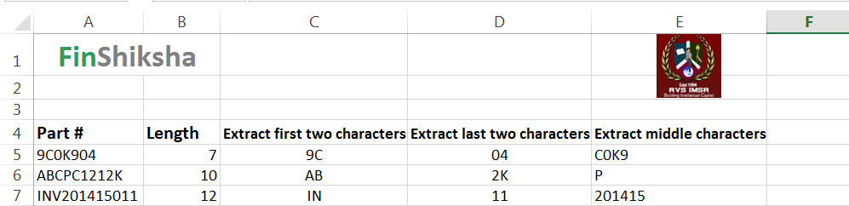

**Aim To describe the usage of Excel String functions LENGTH, MID, RIGHT, LEFT for the given data.**

**Len ()**

**Len function in Excel helps you to know the length of a string that is number of characters in a string. Syntax = LEN (String, Number of Characters)**

**Spaces are included while calculating length.**

**=Len (A5) is 7**

**Left ()**

**Use the Left function when you want to extract the leftmost characters from a string.**

**Syntax**

**=left (String, Number of Characters)**

**Example**

**=Left (A5, 2) is “9C”**

**Right ()**

**Use the Right function when you want to extract the rightmost characters from a string.**

**Syntax**

**=Right (String, Number of Characters)**

**Example**

**=Right (A5, 2) is “04”**

**Mid ()**

**Mid function in Excel is used to extract the characters from the middle of a string.**

**Syntax**

**=MID (String, start_char, num_chars)**

**Example**

**=Mid (A5, 2, 4) is “COK9”.**

**OUTPUT**

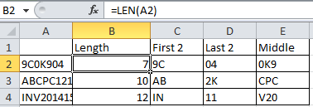

**Illustrate the way to perform SUMPRODUCT function in the below excel sheet.**

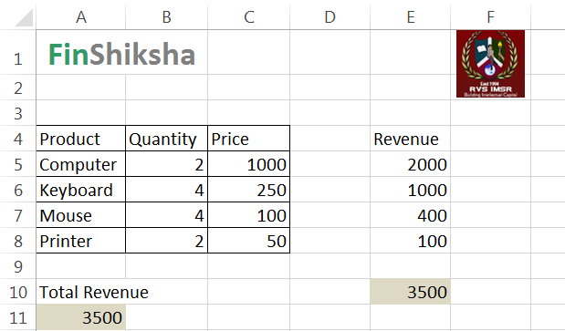

**Aim** Using SUMPRODUCT command to minimize the manual effort of using multiplication and Summation of values

* + - The **SUMPRODUCT** function returns the sum of the products of corresponding ranges or arrays.
    - Instead of using the above method, excel having a function called SUMPRODUCT to calculate that result. We can use the formula in cell E8as below

**Step 1** Open Ms- Excel by using the command **Start -> All programs -> Microsoft Office -> MS Excel.**

**Step 2** Use the SUMPRODUCT formula in the below manner

**=SUMPRODUCT (B3B6, C3C8)**

* + - This will give you your result 3500 in a single command.

**OUTPUT**

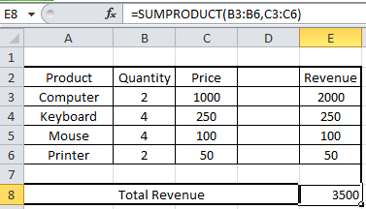

Use Match and Index functions to show the students mark of a specific subject for the below data

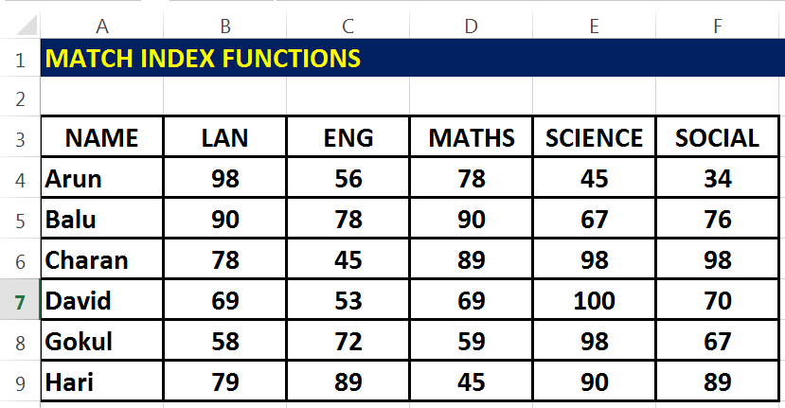

**Aim** Using the Match and Index functionalities to get an expected result with minimum effort.

**Step 1** Open Ms- Excel by using the command **Start -> All programs -> Microsoft Office -> MS Excel.**

**Step 2** Type the given data

**Step 3** Select a cell near to the typed data and first create a list box for the name of the students using the **data validation->allow-list->source select from A3A9** where the name of the students availed,

**Step 4** Follow the same for the subjects also in the next cell to the name list box and select the source from **A3E3**.

**Step 5**

Select any one cell we need the output next to the list boxes as below

|  |  |  |  |  |  |
| --- | --- | --- | --- | --- | --- |
| |  |  |  | | --- | --- | --- | |  |  |  | |  |  |



**Step 6**

And use the index formula in the output cell by selecting the **entire table as array**, then use **match** to identify the **position** of the student by selecting student name list box value as **lookup value**, range is A3A9 and close bracket and give a comma to use match function for the subject by giving subject list box as lookup value,A3E3 as range and give exact match and give enter.

**OUTPUT**

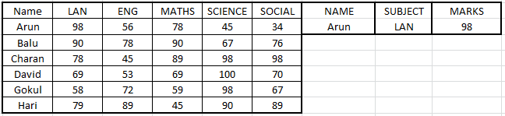

NOTE According to the change in the student name list box and subject list box the marks will be changed.

**Describe the data formatting techniques for the below excel sheet**

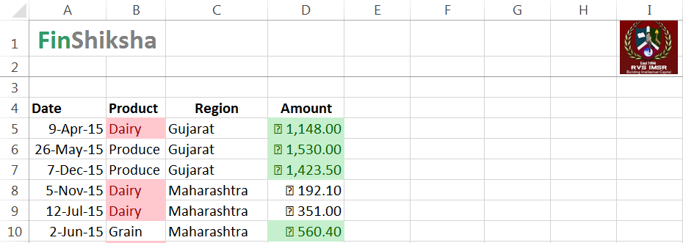

**Aim Using the Conditional formatting to create a rule and formatting the data in an expected manner.**

**Step 1**

Open Ms- Excel by using the command **Start -> All programs -> Microsoft Office -> MS Excel.**

**Step 2**

**Enter the given values in sheet correctly.**

**Step 3To show the amounts in the highlighted color Select** the entered amoumt column data click **Home->conditinal formatting->New rule**

**Step4**

Select the first rule which is **Rule no3->Format only top or bottom ranked values->format values that rank in the->select top->set the value as wanted->format->fill color->select wanted color->ok.**

**Step 5**

**To show the diary product in the highlighted color Select** the entire product column data click **Home->** **Condtional Formatting->Highlight Cell Rules->Equal to->and in the enter diary->select the color and give ok.**

**OUTPUT**

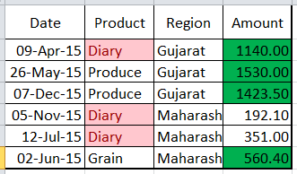

**Write down the steps to Calculate the Depreciation value for the below worksheets**

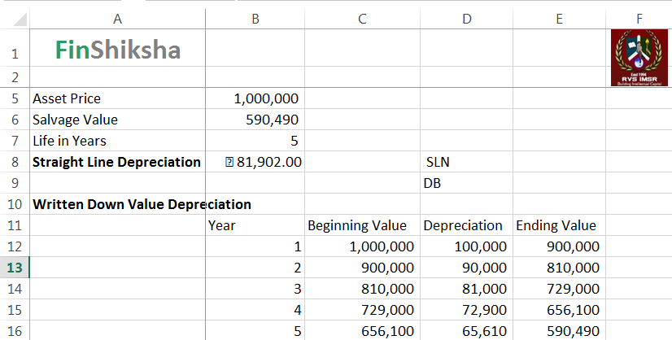

**Aim Using the Excel functions to Calculate the depreciation values.**

**Step 1**

Open Ms- Excel by using the command **Start -> All programs -> Microsoft Office -> MS Excel.**

**Step2**

Enter the given data to calculate Depreciation in the order in excel sheet.

**NOTE**There are two methods to calculate the depreciation

* Straight Line Method (SLN)
* Declining Balance Method (DB)

**Step3**

To calculate the depreciation in straight line method use the formula

= 

**Step4**

Give the appropriate values in the formula.

**OUTPUT**

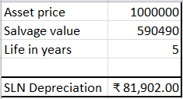

**Step5**

Other method is DB (Declining balance ) method to calculate depreciation .The formula is



OUTPUT

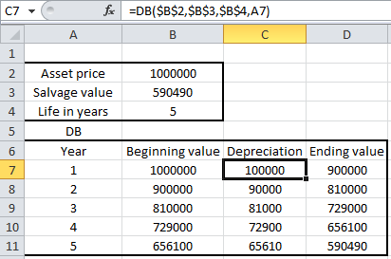

**Write down the steps to create a line chart for the following data**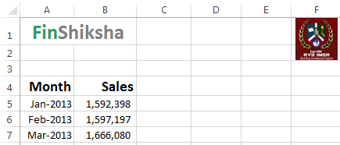

**Aim Creating a line chart for the given data.**

**Step 1**

Open Ms- Excel by using the command **Start -> All programs -> Microsoft Office -> MS Excel.**

**Step2**

Type the given **Month** and **Sales** Values.

**Step3**

Select the **values of Month** and **Sales Price** .

**Step4**

Create a Line chart.

**Step5**

To create a **line chart** click **Insert -> line chart icon.** You will find a line chart.

**Step6**

To add labels right click the data points and then enable **Data Labels** check box.

**Step7**

Add chart title by clicking on it and type your chart name.

**OUTPUT**

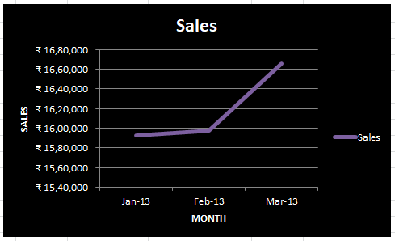

**Write down the steps to create a column chart for the following data**

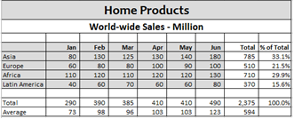

**Aim Creating a column chart for the given data.**

**Step 1**

Open Ms- Excel by using the command **Start -> All programs -> Microsoft Office -> MS Excel.**

**Step2**

Type the given **world wide sales data** Values.

**Step3**

Select the **values of world wide sales data**

**Step4**

Create a column chart.

**Step5**

To create a **column chart** click **Insert -> column chart icon.** You will find a line chart.

**Step6**

To add labels right click the data points and then enable **Data Labels** check box.

**Step7**

Add chart title by clicking on it and type your chart name.

**OUTPUT**

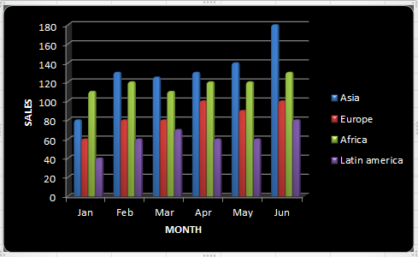

**Write down the steps to create Bar Chart for the following data**

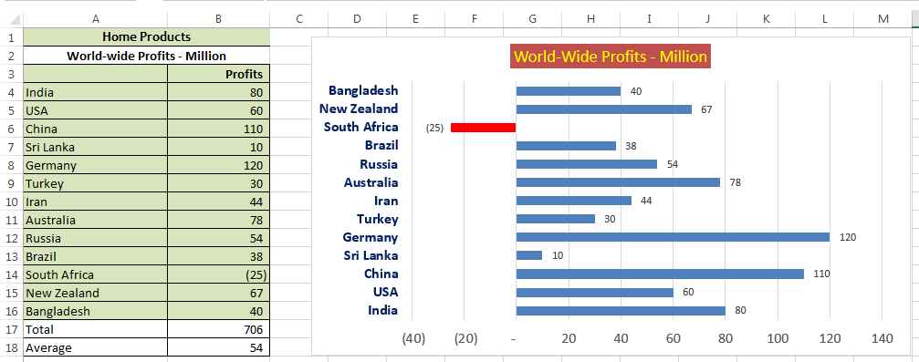

**Aim Creating a Bar Chart with classification of positive and negative values.**

**Step 1**

Open Ms- Excel by using the command **Start -> All programs -> Microsoft Office -> MSExcel**

**Step2.**

Select the entire row of **Home productsof world wide profits-million.**

**Step3**

Then select **the Insert->bar chart** and select the desiredbar chart.

**Step4**

To add labels right click the data points and then enable **Data Labels** check box.

**Step5**

To show the negative value seperately selesct the bar and right click and from the menu select low **format axis->axis options->axis label->low.**

**Step6**

To change the nagative bar **colour select data->right click ->format data series->fill->solid fill->invert if negative->change the second colour as red.**

**Step7**

Add title to the chart by clicking on the **chart Title section.**

**OUTPUT**

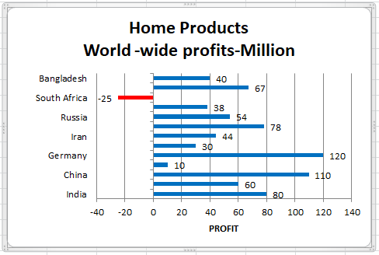

**Given below is the height and weight of a group of 8 people. Plot this on one single chart**

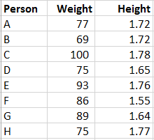

**Aim Understanding the given data and create a Scatter Plot.**

**Step 1**

Open Ms- Excel by using the command **Start -> All programs -> Microsoft Office -> MS Excel.**

Step2

Select the data and click **Insert->Scatter plot**

**Step3**

To change the chart title ,click on it and type the necessary chart title.

**Step4**

To change the chart style,select the style from **Format tab**.

**Step5**

By adding a data label we will get the expected outcome.

**OUTPUT**

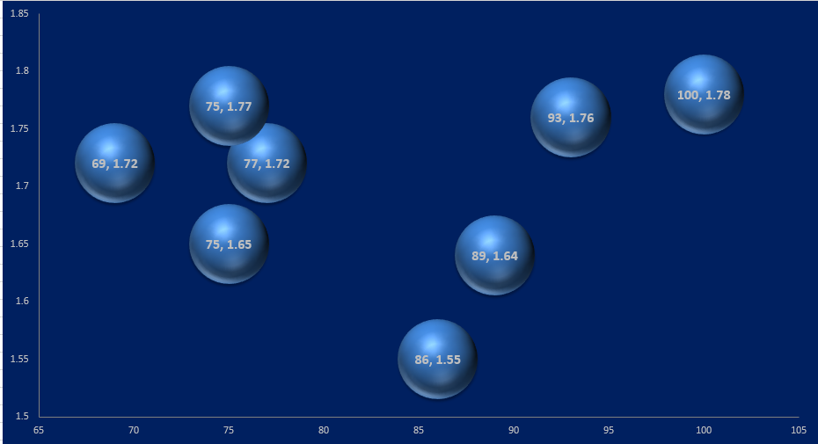

**Given here is a relationship between car density per thousand population and pollution levels in various cities, in ascending order of car density. Plot a chart to show the relationship**

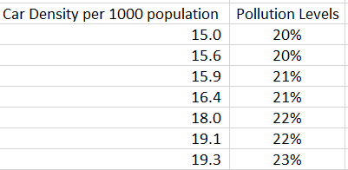

**Aim Understanding the given data and creating the combo chart for representing the given data.**

**Step 1**

Open Ms- Excel by using the command **Start -> All programs -> Microsoft Office -> MS Excel**

**Step2**

Type the given fields **car density and population** and its values.

**Step3**

Select the values of **density and population** data.

**Step4**

Create a combo Chart.

**Step5**

To create a combo chart click **Insert -> column chart(basic chart).**

**Step6**

Select **data points ->change series chart type->line chart->secondary axis.**

**Step7**

To add labels right click the data points and then enable **Data Labels** check box.

**Step8**

Add title to the chart by clicking on the **chart Title section.**

**OUTPUT**

**Given below are some investment details. Calculate the returns on them**

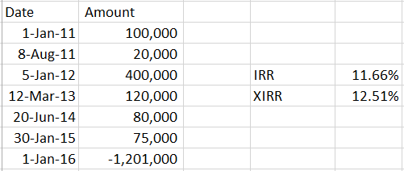

**Aim Calculating the Investment Returns based on the Regular Interval / Irregular Interval.**

**Step 1**

Open Ms- Excel by using the command **Start -> All programs -> Microsoft Office -> MS Excel**

**Step2**

Type the given investment details of columns which include and amount and its values.

**Step3**

Select the given investment details of columns which include and amount and its values.

**Step4**

Firstly to calculate IRR use the formula IRR in which we need output.



**Step5**

Next to calculate XIRR use the formula XIRR in the cell where we need output.



**Step6**

In XIRR formula select all the cashflows including final rerturns,s.

**Step7**

You will get the output.

**OUTPUT**

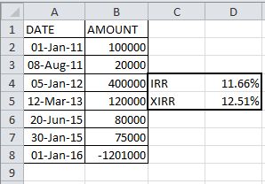

**If a person starts saving Rs 100,000 today, and continue to do it for the next 10 years, when she retires, what is her investment corpus going to be, assuming a 12% return?**

**Aim**

**Using the FV function to calculate the Final Value of an Investment in 10 years with 12% of investment returns of Rs 10000.**

**Step 1**

Open Ms- Excel by using the command **Start -> All programs -> Microsoft Office -> MS Excel**

**Step2**

Type the given savings,no.of years and return percentage data in the new excel spread sheet.

**Step3**

Select the given i savings,no.of years and return percentage data in the new excel spread sheet.

**Step4**

Calculate FV for yearly investment using =investment*(1+Yearly returns).

**Step5**

Specify in the first cell as =B2*(1+$C$12)^D2 and use =sum() for sum of total.

**Step6**

To avoid these n number of steps we can easily calculate by using FV formula as below

**=FV(rate,Nper,-pmt,pv,type)**

**Step7**

Specify the needed cell in the formula as per needed.

**Step8**

**Output**

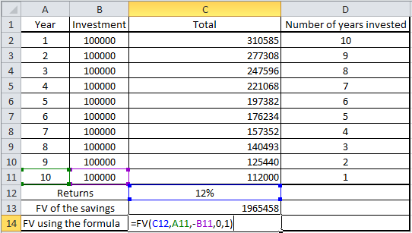

**Assume a person pays taxes on his income at 30%, and there is a surcharge applicable based on certain conditions. How can we consider the various scenarios**

|  |  |  |  |
| --- | --- | --- | --- |
| **Tax Burden** | | **Tax Due** | |
| Year | 2015 |  | **300,000** |
| Surcharge | 0% | 1% | 310,000 |
| Taxable Income | 1,000,000 | 2% | 320,000 |
| Tax Rate | 30% | 3% | 330,000 |

**Aim**

**Using the What-if Analysis -> Data Table function of Excel to calculate the Tax Due dynamically.**

**Step 1**

Open Ms- Excel by using the command **Start -> All programs -> Microsoft Office -> MS Excel**

**Step2**

Type the given income and tax rate in the new excel spread sheet as below

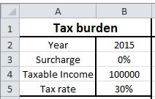

**Step3**

Select the given income and tax rate in the new excel spread sheet.

**Step4**

Fill the cell upto 15 % and calucale tha tax due amount in the before cell by multiplying taxable income * (tax rate+surcharge).

**Step5**

Enter % values for Surcharge from cell C3C17

**Step 6**

Select the data range **C2E17 and select the menu data tab->what-if-analysis->data table.**

**Step6**

A box will be displaying after selecting data table from what-if-analysis as shown below

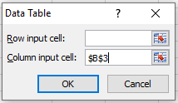

**Step7**

Specify the surcharge cell in column input cell and click ok.

**Step8**

Output will be displayed.

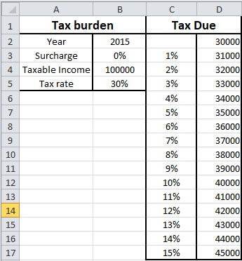

**Ajay has taken a loan of Rs 17 lakhs to buy a car, and is expected to pay a 12% interest on it over 7 years. Calculate the equated monthly installments (EMIs)**

|  |  |  |
| --- | --- | --- |
| Car Loan | 1,700,000 |  |
| Interest Rate | 12% | 1% |
| Tenure (Years) | 7 |  |

**Aim**

**Calculating the EMI and Principal Repayment Amount using the Excel Functions.**

**Step 1**

Open Ms- Excel by using the command **Start -> All programs -> Microsoft Office -> MS Excel**

**Step2**

Type the monthly installments in the new excel sheet with necessary details.

**Step3**

Create the column as below

|  |  |  |  |  |  |
| --- | --- | --- | --- | --- | --- |
| Month | Principal outstanding | Interest repayment | Principal repayment | EMI | PPMT |

**Step4**

To specify the month here sum the total years is 7 and the number of month is 12 =84 and drag upto 84 months.

**Step5**

Specify the principal outstanding by giving =car loan the in the first cell of principal outstanding.

**Step6**

Specify the intrest repayment by multiplying =principal outstanding*intrest rate of month that is 1%.

**Step7**

Before calculating principal repayment calulate EMI by using the formula =PMT() specify the needed ranges and in the next row give =first cell of EMI and drag for the rest.

**Step8**

Now calculate principal repayment by =EMI-Intrest.

**Step9**

Specify the ppmt column by using the ppmt formula.

**Step10**

**NOTE**

* Use the PMT function for payment of EMI calculation.
* **=pmt(intrest rate,repayment period,-loancamount)**
* For intrest calculation=principal outstanding*intrest rate
* For principal calculation=EMI-intrest
* For PPMT calculation=**PPMT(intrest rate,repayment period in range,no.of.months,-loan amount).**

**Output**

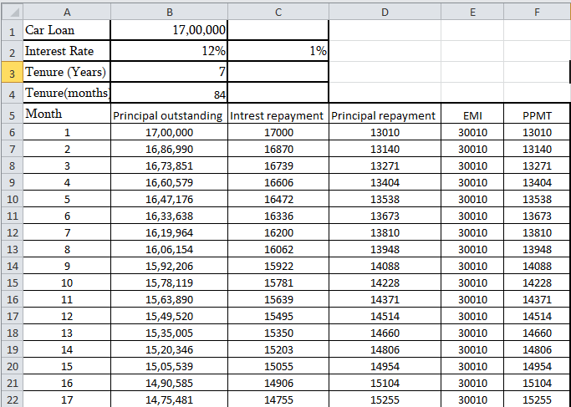

**NOTE** Output will be extended here for space convenient few out is only given.

**Given below are details of values of 3 stock market indices, India, Japan and the USA. Based on the values available - create a table with the details represented in an error free format, calculate statistical parameters for the indices - such as returns and risk, and represent the relative movement in the form of a chart**

|  |  |  |  |  |  |  |  |
| --- | --- | --- | --- | --- | --- | --- | --- |
|  | **Nifty** |  |  | **Nikkei** |  |  | **Dow Jones** |
| 1/4/2010 | 5232.2 |  | 1/4/2010 | 10654.79 |  | 1/4/2010 | 10583.96 |
| 1/5/2010 | 5277.9 |  | 1/5/2010 | 10681.83 |  | 1/5/2010 | 10572.02 |
| 1/6/2010 | 5281.8 |  | 1/6/2010 | 10731.45 |  | 1/6/2010 | 10573.68 |
| 1/7/2010 | 5263.1 |  | 1/7/2010 | 10681.66 |  | 1/7/2010 | 10606.86 |
| 1/8/2010 | 5244.75 |  | 1/8/2010 | 10798.32 |  | 1/8/2010 | 10618.19 |
| 1/11/2010 | 5249.4 |  | 1/12/2010 | 10879.14 |  | 1/11/2010 | 10663.99 |
| 1/12/2010 | 5210.4 |  | 1/13/2010 | 10735.03 |  | 1/12/2010 | 10627.26 |
| 1/13/2010 | 5233.95 |  | 1/14/2010 | 10907.68 |  | 1/13/2010 | 10680.77 |
| 1/14/2010 | 5259.9 |  | 1/15/2010 | 10982.1 |  | 1/14/2010 | 10710.55 |
| 1/15/2010 | 5252.2 |  | 1/18/2010 | 10855.08 |  | 1/15/2010 | 10609.65 |
| 1/18/2010 | 5274.85 |  | 1/19/2010 | 10764.9 |  | 1/18/2010 | #N/A |
| 1/19/2010 | 5225.65 |  | 1/20/2010 | 10737.52 |  | 1/19/2010 | 10725.43 |
| 1/20/2010 | 5221.7 |  | 1/21/2010 | 10868.41 |  | 1/20/2010 | 10603.15 |
| 1/21/2010 | 5094.15 |  | 1/22/2010 | 10590.55 |  | 1/21/2010 | 10389.88 |
| 1/22/2010 | 5036 |  | 1/25/2010 | 10512.69 |  | 1/22/2010 | 10172.98 |

**Aim**

**Organize and Process the Share market Data and Perform Statistical Measures and Prepare a Chart for Representation of the Data.**

**Step 1**

Open Ms- Excel by using the command **Start -> All programs -> Microsoft Office -> MS Excel**

**Step2**

Type the entire shares values of Nifty,Nikai and Dow Jones in the new excel sheet.

**Step3**

First give the heading in the new sheet as below

|  |  |  |  |  |  |  |  |  |  |
| --- | --- | --- | --- | --- | --- | --- | --- | --- | --- |
|  | **Index Values** | | | **Index Returns** | | | **Normalized Index** | | |
|  | **Nifty** | **Nikkei** | **Dow Jones** | **Nifty** | **Nikkei** | **Dow Jones** | **Nifty** | **Nikkei** | **Dow Jones** |

**Step4**

First copy the all three shares in the cell and remove duplicate and sort the column.

**Step5**

Use the VLOOKUP formula to fill the share values in all three shares in Index Values as below vlookup formula

**=VLOOKUP(A3,Sheet10!$A$2$B$1429,2,0)**

**=VLOOKUP(A3,Sheet10!$D$3$E$1429,2,0)**

**=VLOOKUP(A3,Sheet10!$G$3$H$1429,2,0)**

**Step5**

In the Index Returns in all three shares subratct the second share value from each shares by previous day shares.

**=(B4-B3)/B3**

**=(C4-C3)/C3**

**=(D4-D3)/D3**

**Step6**

Atlast in the Normalised Index Values asuume 10000 in all shares and calculate as below in all the three shares

**=H3*(1+E4)**

**=I3*(1+F4)**

**=J3*(1+G4)**

**Step7**

Drag it for all the below cells and get the output.

Step 8

Calculate the Statistical Values and Draw Line Chart for the Organized Data.

**OUTPUT**

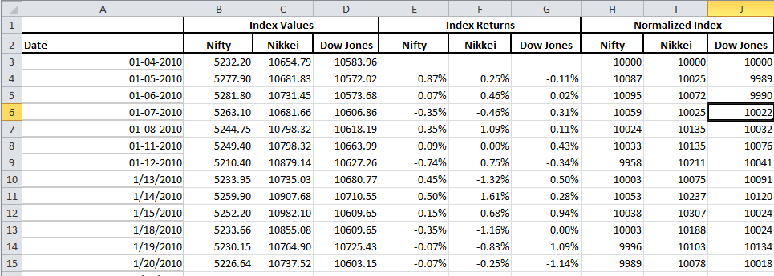

**Given below are details of financials of a company's various subsidiaries. The subsidiaries operate in different business segments, and you are supposed to represent the data in the best possible manner so as to derive meaningful information out of this**

|  |  |  |  |  |  |  |
| --- | --- | --- | --- | --- | --- | --- |
| Subsidiary 1 - Foods and Beverages |  |  |  |  |  |  |
|  | 2010 | 2011 | 2012 | 2013 | 2014 | 2015 |
| Sales | 950 | 1044 | 1200 | 1300 | 1280 | 1331 |
| Operating Profits | 123 | 125 | 144 | 169 | 179 | 159 |
| Net Profit | 60 | 67 | 72 | 73 | 77 | 74 |
| Marketing Expenses | 150 | 170 | 200 | 210 | 223 | 187 |
| Market Share in segment | 2.20% | 2.40% | 2.50% | 2.40% | 2.30% | 2.40% |
|  |  |  |  |  |  |  |
| Subsidiary 2 - Media |  |  |  |  |  |  |
|  | 2010 | 2011 | 2012 | 2013 | 2014 | 2015 |
| Sales | 670 | 740 | 800 | 900 | 1100 | 990 |
| Operating Profits | 13 | 15 | 16 | 14 | 21 | 19 |
| Net Profit | -10 | -15 | -20 | -43 | -25 | -24 |
| Marketing Expenses | 200 | 250 | 300 | 350 | 400 | 384 |
| Market Share in segment | 10.00% | 11.00% | 12.00% | 11.00% | 12.50% | 11.00% |
|  |  |  |  |  |  |  |
| Subsidiary 3 - Infrastructure |  |  |  |  |  |  |
|  | 2010 | 2011 | 2012 | 2013 | 2014 | 2015 |
| Sales | 7680 | 8000 | 7569 | 7430 | 6900 | 7935 |
| Operating Profits | 376 | 392 | 454 | 409 | 338 | 298 |
| Net Profit | 200 | 187 | 227 | 178 | 144 | 133 |
| Marketing Expenses | 900 | 800 | 1023 | 1090 | 1200 | 1044 |
| Market Share in segment | 5.00% | 5.00% | 6.00% | 6.50% | 7.20% | 8.00% |
|  |  |  |  |  |  |  |
| Subsidiary 4 - Cement |  |  |  |  |  |  |
|  | 2010 | 2011 | 2012 | 2013 | 2014 | 2015 |
| Sales | 1600 | 1700 | 2000 | 1900 | 1800 | 1818 |
| Operating Profits | 272 | 323 | 360 | 380 | 342 | 294 |
| Net Profit | 139 | 166 | 189 | 165 | 190 | 194 |
| Marketing Expenses | 80 | 80 | 100 | 100 | 100 | 94 |
| Market Share in segment | 3.40% | 3.60% | 4.00% | 4.00% | 4.50% | 4.20% |

**Aim Prepare and Process the Data and Present the data as a Dashboard**

**Step 1** Open Ms- Excel by using the command **Start -> All programs -> Microsoft Office -> MS Excel.**

**Step 2** Type the given data as a data named excel sheet.

**Step 3** Type the title of four subsidiaries from the data in the other excel sheet named dashboard next by next.

**Step 4** Create a list box for subsidiary, their parameter and for the year.

**Step 5** Create a other sheet named organize data and copy and paste the values from the data as below



**Step 6**

Copy and paste the values from the data sheet as below

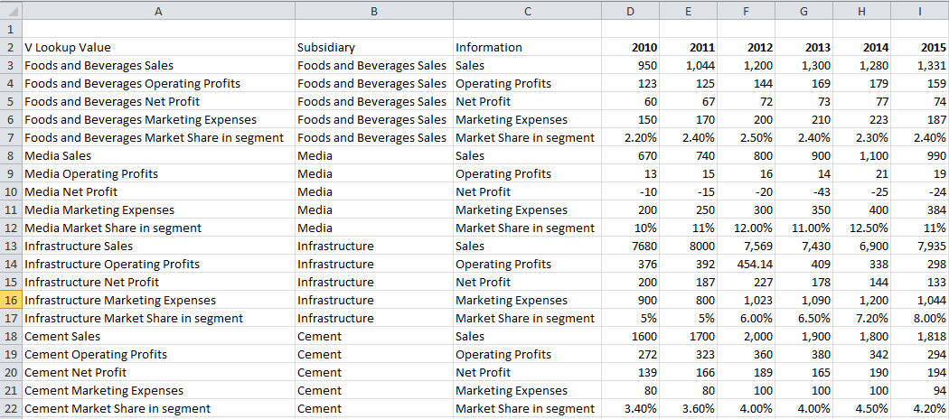

**Step 7**

Fill the year column in the dashboard by preferring the previous cell+1

**Step 8**

Select the cell where we need the output and use VLOOKUP formula as below

**VLOOKUP ($B$13, 'ORGANISEDATA'!$A$3$I$22, MATCH(DASHBOARD!C10, 'ORGANISE DATA'!$A$2$I$2), 0)**

**Step 9**

Then drag it for rest of the cells and create a basic 2D column chart.

**OUTPUT**

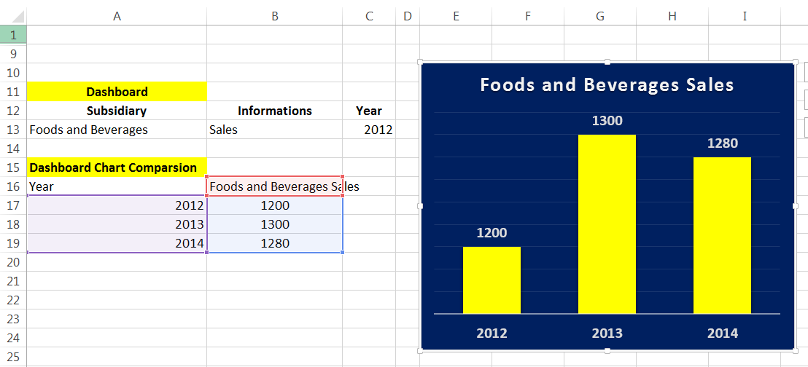

**Describe the Exact VLOOKUP using the below excel sheet.**

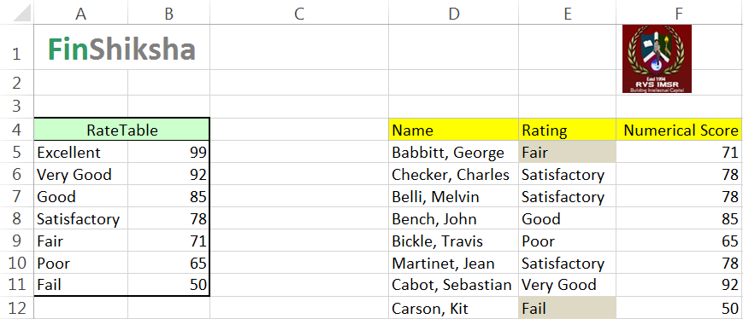

**Aim**

Using the VLOOKUP function to calculate the Numerical Score Based on the Rating.

**Step 1** Open Ms- Excel by using the command **Start -> All programs -> Microsoft Office -> MS Excel.**

**Step 2** Type the given data

**Step 3** To calculate the above data use the formula VLOOKUP formula

=VLOOKUP (**lookup value**, **table array**, **col_index_num**, [**range_lookup**])

**Step 4**

**Lookup value** Select the cell where search values will be entered.

**Table array** The table range, including all cells in the table.

**Col_index_num** The data which is being looked up. The input is the number of the column, counted from the left

**Range lookup** TRUE if numbers (1) or FALSE if text (0).

**Step 5** Enter theappropriate values in the formula

**Step 6** Press Enter Button.

**OUTPUT**

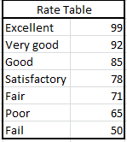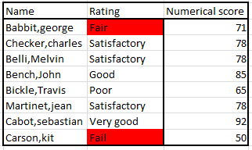

**For Kannan Departmental Stores, dynamically visualize the sales data details for the given interval item wise input criteria**

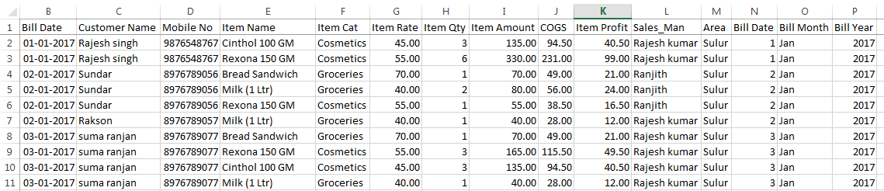

**Aim**

**Prepare the Sales Dashboard using the SUMIFS function with Sales and Item Name input Parameters.**

**Step 1**

Open Ms- Excel by using the command **Start -> All programs -> Microsoft Office -> MS Excel.**

**Step 2**

Type the given data of monthly wise sales data including all columns.

**Step 3**

Create a boundary by filling color in a box shaped as below

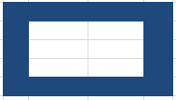

**Step4**

In the first three rows give from ,to and items name next to next and give their value .

**Step5**

for from is specify from day 1

**Step6**

for to day is from +7

**Step7**

Item name filter and remove duplicate values and create a list box by clicking data tab->data validation=> list and mention the source.

**Step8**

To design the header Insert->shapes->Drawing tools->format->bevel and same as for text.

**Step9**

Now populate the data as and sales in the corner of the created border color filled box

**Step10**

is specify from in the first cell and drag for the remaining cells.

**Step11**

For sales use SUMIFS formula as below

**Sumifs(sum_range,creiteria_range[criteria1,creiteria2..])**

**Step12**

Sum range is Item amount from the data,criteria range is column from the data and criteria1 will be the from data from the dashboard and criteria 2 will be item name cell from the dashboard cell and freeze the necessary cells.

**Step13**

Then by selecting the data and sales data in the dashboard create a column chart which will fit the dashboard.

**Step14**

Add data labels by right click on the chart and add data label

**Step15**

Select the bar in the chart and right click->format data series->fill->vary by colors.

**Output**

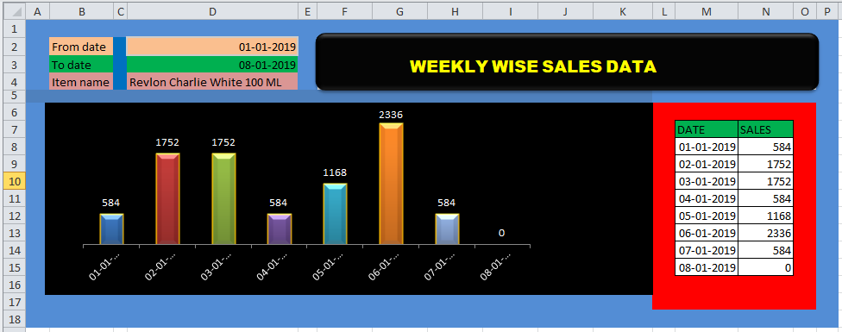

**Write down the steps for create an Item wise Sales Report and present in Column Chart using Pivot table concept**



**Aim**

**Prepare the Monthly Sales Dashboard using the Pivot Table Concepts.**

**Step 1**

Open Ms- Excel by using the command **Start -> All programs -> Microsoft Office -> MS Excel.**

**Step 2**

Type the given data of monthly wise sales data including all columns.

**Step 3**

Select the entire data sheet **Insert->Pivot table**

**Step 4**

A new sheet will be created with pivot table details as below

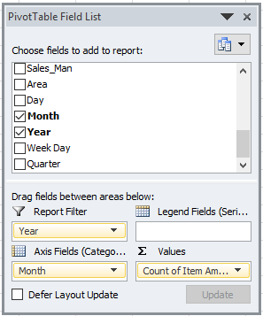

**Step 5**

Specify bill month column in rows category.

**Step 6**

Specify Item amount in values by changing the values from count to sum by right clicking value field

Change.

**Step 7**

Also specify bill year in filter section.

**Step 8**

Then by selecting analyze tab create a pivot chart .So a chart will be displayed with several field buttons.

**Step 9**

To remove the field buttons select the field button right click and click hide axis or hide all field button.

**Step 10**

After creating the chart give the needed designs by selecting the design tab.

**OUTPUT**

**Table**

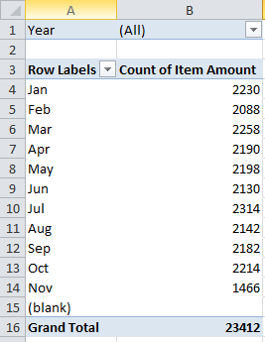

**Pivot chart**

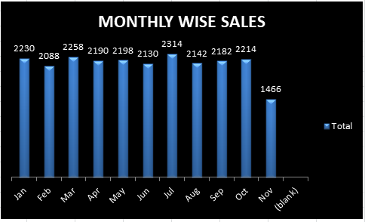

**Assuming below are your scores in 4 matches, how much would you have to score in the next cricket match to reach an overall average of 55 using Goal Seek Analysis.**

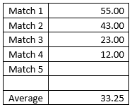

**Aim**

**Using Goal Seek Analysis to Calculate the Match 5 Score**

**Step 1**

**Enter the data in the Excel Sheet as shown above.**

**Step 2**

**Calculate the Average using the below formula**

**=AVERAGE(B3B7)**

**Step 3**

**Use the below Menu we will get the below sub menu.**

**Data -> What-If Analysis -> Goal Seek**

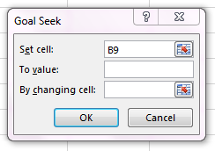

**Step 4**

**Set Cell value has been entered cell address B9 which has the average formula entered.**

**Step 5**

**To Value to be entered should be 55, since the expected overall score as 55.**

**Step 6**

**By changing Cell should be entered as B7 which is currently does not have any value and it should be calculated.**

**Step 7**

**Click the Ok button we will get the expected result.**

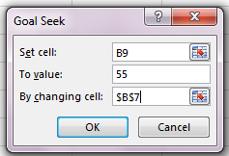 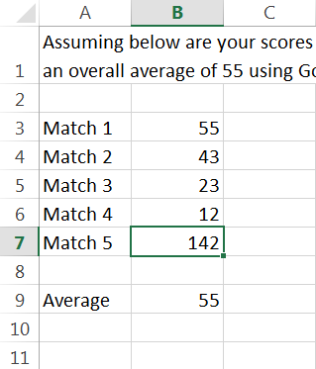

**Case Study**

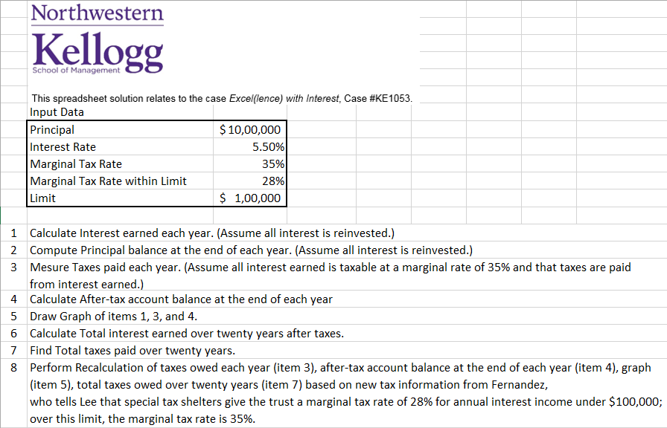

**Aim To Calculate the Interest earned and Principal balance without Tax / With Marginal Interest Rate / With Marginal Tax within Limit.**

1. **Calculate Interest earned each year. (Assume all interest is reinvested.)**

**Scenario I - No Tax**

Perform the below calculation for Interest Earned

=C14*$D$4

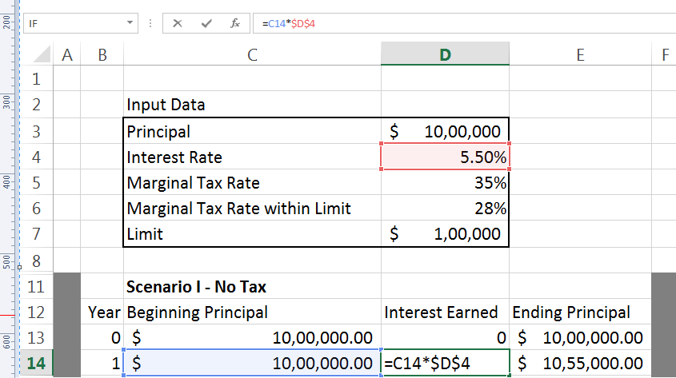

1. **Compute Principal balance at the end of each year. (Assume all interest is reinvested.)**

Perform Principal Balance at the end of the year using the below command

= C14 + D14

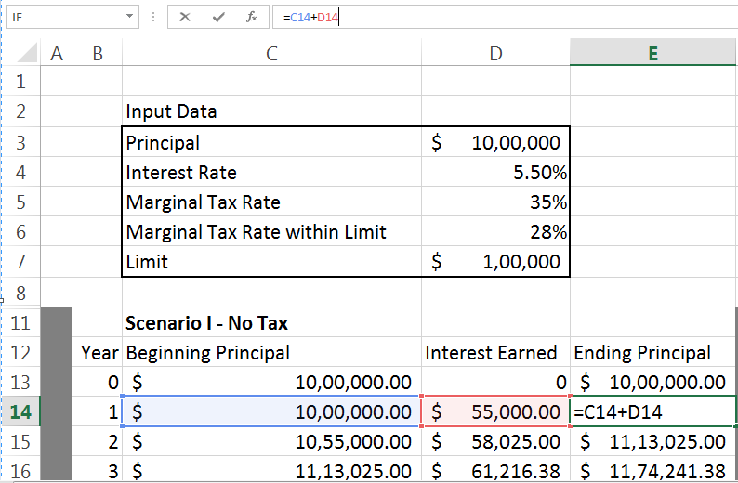

1. **Measure Taxes paid each year. (Assume all interest earned is taxable at a marginal rate of 35% and that taxes are paid from interest earned.)**

Taxes paid each year calculated using the below command

= H14 + I14

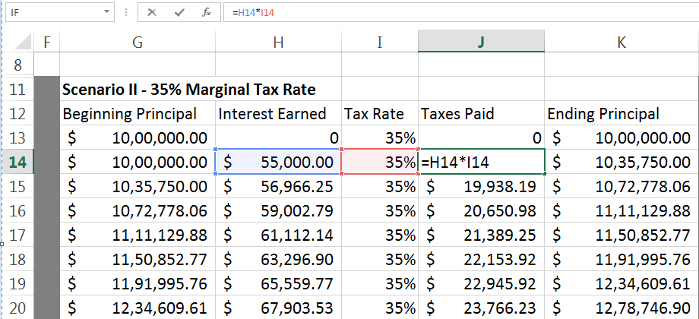

1. **Calculate After-tax account balance at the end of each year**

Account Balance after-tax at the end of the year has calculated using the below command

= G14 + H14 – J14

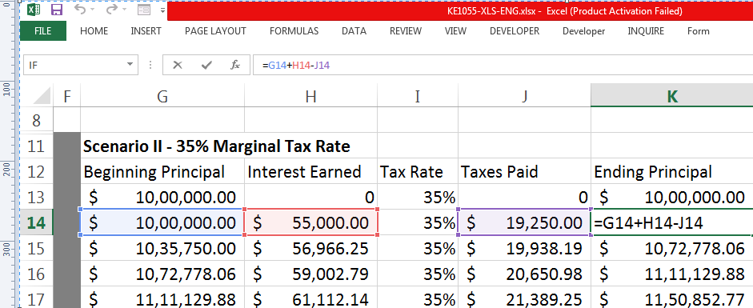

1. **Draw Graph of items 1, 3, and 4.**

**Use the Line Graph select the required columns Interest Earned (H Column), Taxes Paid (J Column) and Ending Principal (K Column) of Scenario II - 35% Marginal Tax Rate**

1. **Calculate Total interest earned over twenty years after taxes.**

Perform the below calculation for Total Interest earned over 20 years after taxes

=SUM (Calculations! H13H33)

1. **Find Total taxes paid over twenty years.**

Perform the below calculation for Total taxes paid over 20 years

=SUM (Calculations! J13J33)

1. **Perform Recalculation of taxes owed each year (item 3), after-tax account balance at the end of each year (item 4), graph (item 5), total taxes owed over twenty years (item 7) based on new tax information from Fernandez, who tells Lee that special tax shelters give the trust a marginal tax rate of 28% for annual interest income under $100,000; over this limit, the marginal tax rate is 35%.**

**For this , use the Scenario III - 28% Marginal Tax Rate under $100k, 35% thereafter) select the Interest Earned (Column N), Taxes Paid (Column P) and Ending Principal (Column Q). Select the Line Graph and use the above mentioned data we will get the below Chart**

